A000-Eur-Roman-Rhyton-Horse-Bronze-100 CE

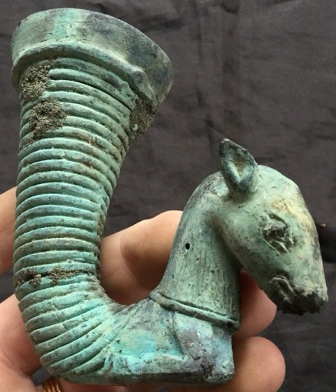

Roman-Rhyton-Horse-Bronze-100 CE

**Case no.: 4**

**Accession Number:**

**Formal Label:** Roman-Rhyton-Horse-Bronze-100 CE

**Display Description:** Bronze Roman Rhyton with a horse’s head. From a private British collection. Rhyta occur among the remains of civilizations speaking different languages and language groups in and around the Black sea and Middle East from the second millennium BCE. This horse’s head may have functioned as an emblem for a Roman cavalry unit. Animals' heads suggest an emblematic function. For instance the bull in Minoan Crete was an important emblem in bull jumping athletics and several bull rhyta have been excavated in the great palaces and are now on display in the Iraklion Archaeological Museum.

Rhyta were very common in ancient Persia, where they were called *takuk* (تکوک). After a Greek victory against Persia, much silver, gold, and other luxuries, including numerous rhytons, were brought to Athens. Persian rhyta were immediately imitated by Greek artists. Not all rhyta were so valuable; many were simply decorated conical cups in ceramic.

**LC Classification: DG 89**

**Date or Time Horizon:** 500 BCE

**Geographical Area:**

**Map:**

**GPS coordinates:**

**Cultural Affiliation:**

**Media:**

**Dimensions:** H 10 cm x W 10 cm, Dia 4.5 cms

**Weight:** 194 **gm**

**Condition: original**

**Provenance:** From a private British collection.

References:

Koehl, R.B., 2006. *Aegean Bronze Age Rhyta*. Institute for Aegean Prehistory Press.

Parker, Henry Michael Denne. 1993. *The Roman Legions*. New York, N.Y.: Barnes & Noble.